CERTIFICATION OF VALIDITY
OF MEMORANDUM OF AGREEMENT

This is to certify that the Memorandum of Agreement (MOA) entered into by and between:

[NAME OF FIRST PARTY / INSTITUTION]

and

City of Malabon University

remains valid, binding, and in full force and effect as of this date.

The said agreement covers the terms and conditions relating to Partnership, and both parties have agreed to uphold their respective roles and responsibilities as stipulated in the document.

Issued this __________________
(date of issuance)

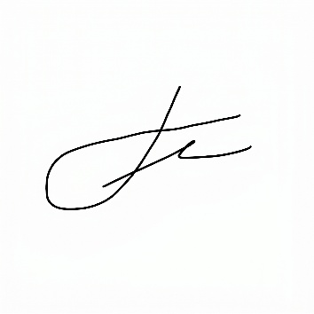
Certified by:

Engr. Jed G. Concepcion
Head, Business Linkages and Partnership
City of Malabon University

